**AWH ENGINEERING COLLEGE**

**KUTTIKKATTOOR, CALICUT-8**

# *PROJECT REPORT PHASE 1*

***ON***

**INNCITY**

***SUBMITTED IN PARTIAL FULLFILLMENT***

***OF THE REQUIREMENTS FOR THE***

***AWARD OF THE DEGREE***

***OF***

**BACHELOR OF TECHNOLOGY**

***IN***

**COMPUTER SCIENCE & ENGINEERING**

***BY***

**ALEN THOMAS**

**ANANDHU P P**

**LIGIN VELLAKKAD**

**NIKHIL NARAYANA KURUP**

**IBRAHIM KHALEEL K**

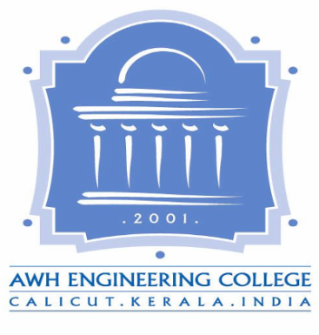

**DEPARTMENT OF COMPUTER SCIENCE & ENGINEERING**

**AWH ENGINEERING COLLEGE**

**KUTTIKKATTOOR, CALICUT-8**

**OCTOBER 2014**